IT 166 Lab 14

Plotting in Python

Objectives

* Be able to plot figures using matplotlib and pandas.

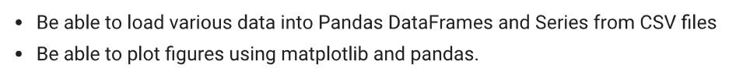

Preparation

* Launch the Jupyter notebook.
* Rename the notebook page as “lab14”.
* Solution to one problem should occupy one cell.

Please provide solutions to the problems below.

Problem 1

Use matplotlib to plot sin(x) and cos(x), where x is in [-8,8] Requirements:

1. Two plots should co-exist in one figure.
2. Use NumPy to generate x, where x is in [-8,8] with a step of 0.1 3) For the sin(x), set the plot to be green-dashed line with no markers.
3. For the cos(x), set the plot to be red dots.
4. Set the limit of x axis as [-10,10]. 6) Set the limit of y axis as [-2,2].

7) Set the legend using the ‘best’ parameter.

Expect outcome:

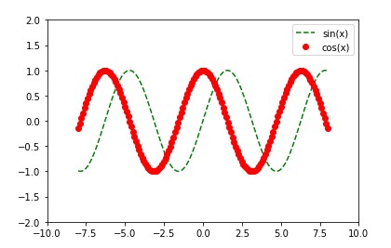

Problem 2

Use pandas to read the “tips.csv” file into a DataFrame. Create a figure that has four subplots, arranging the plots using a 2 by 2 mesh:

1. The top-left figure is a histogram of the column, “tip”. Set the color to be green and the number of bins is ten.
2. The top-right figure is a histogram of the column, “day”. You will need to use the following statement to group the column: grouped = df[‘day’].groupby(df[‘day’]) before plotting the histogram.
3. The bottom-left figure is a box-plot of the column, “tip”.
4. The bottom-right figure is a histogram of the column, “size”.

Expect outcomes:

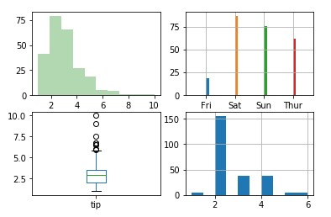

Problem 3



directory.

